University of California PD, Berkeley

Daily Crime Log
07/08/2026 00:00 - 07/08/2026 23:59

Case #
Crime(s)
Reported: Occurred Range:
Location(s):
Disposition

26-01695 | 484G: PC; Theft By Use Of Access Card Information; Misdemeanor | 07/08/2026 12:48 | 06/27/2026 *00:01 2607 Hearst Av; Goldman School of Public Policy *Inactive: 7/8/2026  *6/27/26 *23:59
26-01696 | OUT WRTF: Other Agency Warrant, Fel | 07/08/2026 13:04 | 07/08/2026 13:04 | Red Oak Av & Sixth St | Closed: 7/8/2026
 | 485: PC; Appropriate Lost Property; Felony
26-01697 | 459: PC; Burglary:first Degree; Felony | 07/08/2026 17:53 | 06/19/2026 09:26 | 1110 Jackson St; UVA-132 | Inactive: 7/8/2026
 |  |  | 6/20/26 8:12
26-01698 | 20002 (A): VC; Hit and Run:property Damage; Misdemeanor | 07/08/2026 19:26 | 07/08/2026 19:26 | University Village; UVA | Active: 7/8/2026
 | SUPP: Supplemental Reports

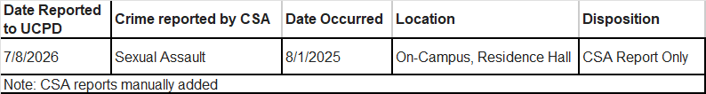

*MANUALLY ADDED / EDITED
Page 1 of 1 APDC (Rev. 09/04/18) Print Date: 07/09/2026

