University of California PD, Berkeley

Daily Crime Log
06/02/2026 00:00 - 06/02/2026 23:59

Case # | Crime(s) | Reported: | Occurred Range: | Location(s): | Disposition
26-01472 | SUPP: Supplemental Reports | 06/02/2026 02:45 | 06/02/2026 02:45 | Red Oak Av & Gooding Wy | Closed: 6/2/2026
11377(A): HS; Possess Controlled Substance;
Misdemeanor
 | 11364(A): HS; Possess Unlawful Paraphernalia; Misdemeanor
26-01473 | 2800(A): VC; Fail To Obey Peace Officer:lawful | 06/02/2026 03:04 | 06/02/2026 03:04 | Harrison St & Ninth St | Closed: 6/3/2026
 | Order Or Inspection; Misdemeanor
 | 148(A)(1): PC; Obstruct/Resist/Etc Public/Peace
 | Officer/Emergency Med Tech; Misde
 | 166(A)(4): PC; Contempt Of Court:disobey Court
 | Order/Etc; Misdemeanor
 | *530.5(E): PC; Possess Stolen Mail; Misdemeanor
26-01474 | PRODAM: Property Damage | 06/02/2026 12:13 | 06/01/2026 08:30 | South Hall | Inactive: 6/2/2026
 |  |  | 6/1/26 17:00
26-01475 | Caslty: Injury/Illness | 06/02/2026 14:38 | 06/02/2026 14:38 | 2951 Derby St; Redwood Gardens | Inactive: 6/2/2026

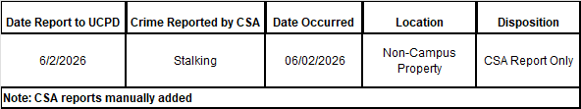

*Manually Added / Edited Page 1 of 1 APDC (Rev. 09/04/18) Print Date: 06/03/2026

